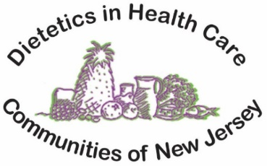

In-Person Spring Seminar
Location: CentraState Medical Center Conference Room
901 West Main Street, Freehold, NJ 07728
Date: Thursday, May 4, 2023
Time: 9 am -3:00 pm
Facilitator: Donna Hunter, Chairperson

8:00 am- 8:30 am: Registration

8:30am- 9:00 am: Business Meeting

9:00 am -10:15 am
Topic: The Connection between Nutrition, Oral Health and Chronic Disease
Presenter: Diane L. Rigassio-Radler, PhD RDN, Associate Professor, Diagnostic Sciences
From: Rutgers School of Dental Medicine

10:30 am – 11:45 am
Topic: Nutrition Considerations in Nonalcoholic Fatty Liver Disease (NAFLD) and Nonalcoholic Steatohepatitis (NASH)
Presenter: Deborah Cohen, DCN, RDN, Associate Professor Department of Clinical and Preventive
Nutrition Sciences
From: Rutgers University-School of Health Professions

11:45 am –12:30 pm Lunch Break
12:30 pm – 3:00 pm
Topic: Trends in Parenteral & Enteral Feeding: Calculations, and Transition to Oral Feedings

Presenter: Jennifer Bridenbaugh MS RDN CNSC, Assistant Professor, Department
of Clinical and Preventive Nutrition Science
From: Rutgers University – School of Health Professions

To Sign up: Please visit our website at www.njnutritionexpert.com to register and pay using the on-line system. It is an easy, one step process. You will be issued a registration confirmation with the direct link to handouts and directions to the conference center. Registration Deadline: 5-1-23 @12 Midnight. If unable to register on-line mail checks to: Karen Fivek: 19 Plantation Rd Whitehouse Station, NJ 08889. 5 CEUs requested for seminar.
Includes: Continental Brkft, Snacks, & Lunch-Members: $70 Non-Members: $90 Students: $35

