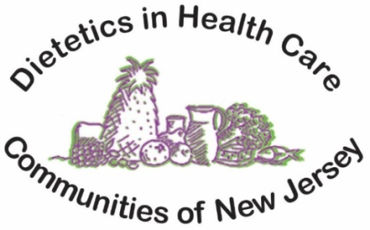

SPRING VIRTUAL CONFERENCE!
Date: Tuesday, April 26, 2022
Time: 9:00am -3:00pm

Welcome and Business Meeting: 9:00am
Facilitator: Mary Piciocco, Chairperson

Topic: Nutritional Management of Neurological Disorders 9:30-11:00am

Presenter: Dr. Phyllis Famularo DCN, RD, CSG, LDN, FAND
Senior Manager-Sodexo
Explore Nutrition Strategies for the care of individuals with Parkinson’s Disease, MS, ALS and HD.

- Topic: Integrative Approaches to Address Micronutrient Deficiencies 11:00am-12:00pm

Presenter: Alison Reyes, MS, RDN, LDN, IFNCP, Internship Director-Sodexo Healthcare Services
Discuss the presence and potential causes of micronutrient deficiencies and safety/effectiveness of supplementation in older adults.
Break: 12:00pm-12:30pm

Topic: Promoting Brain Health through Lifestyle and Nutrition 12:30- 2:00pm Presenter: Kelly H. Cuetara MS RD LDN,Clinical Dietitian/Dining Service Mgr, Sodexo Senior Living
Define neural protections against cognitive decline, biological and lifestyle risk factors and nutrition
Roles in maintaining brain health.

Topic: Positive Connections: Understanding how to Engage your 2:00- 3:00pm Compromised Resident for Improved Nutrition Outcomes

Presenter: Beth Nolan, PhD, Director of Research and Policy, Positive Approach LLC
Identify positive approaches in engaging your clients at their cognitive level to improve their success at nutrition and hydration management
Board Meeting to Follow after webinar

Cost: Members $40 Non-Members: $50 Students: $25
To Sign up: Please visit our website at www.njnutritionexpert.com to register.
Deadline: Friday, April 22, 2022 5 C.E.U. total credits (Academy of Nutrition and Dietetics)
For Checks: Mail to Pat Matthews, Treasurer, 16 Hillside Avenue, Jamesburg, NJ 08831

